1. 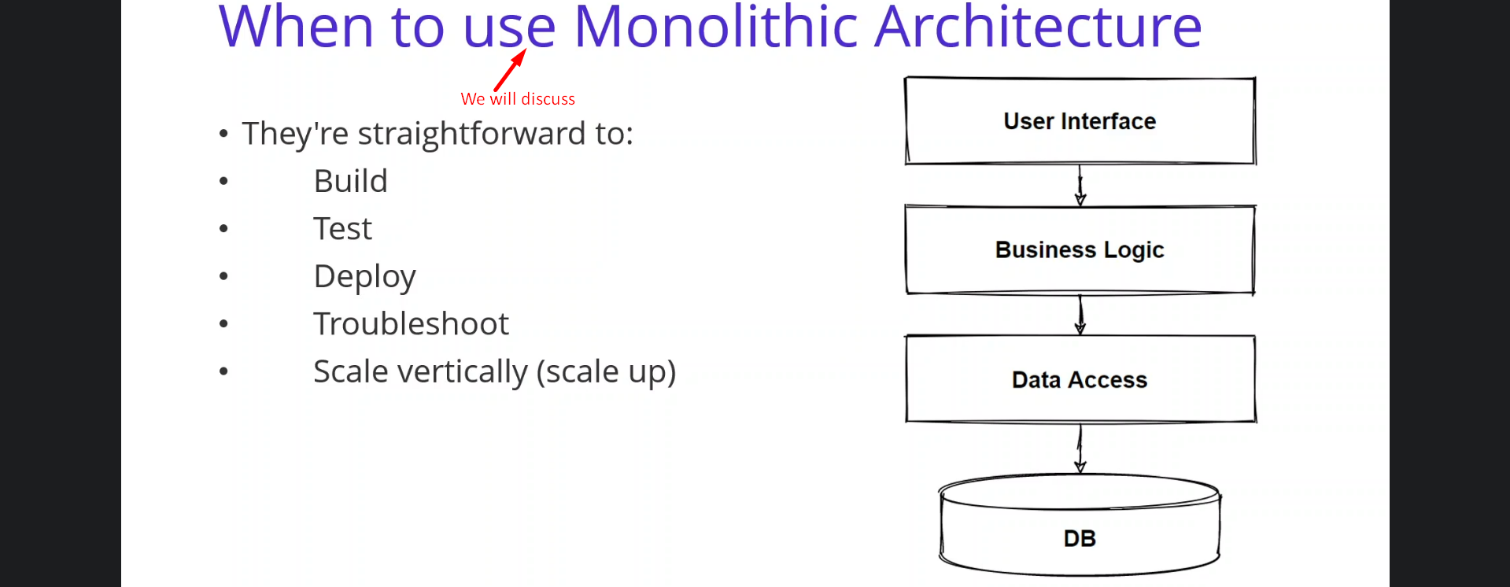
2. Since monolithic architecture has a lot of advantages, if you’re building a small sized app, monolithic architecture is one of the best architectures, that you can apply.
3. Why this architecture:
   1. They’re straightforward to
      1. Build: In ms, skilled developers are required.
      2. Test
      3. Deploy: As a single jar/war is generated and deployed.
      4. Troubleshoot
      5. Scale Vertically (scale up): If you don’t expect hundred of requests, you can scale it vertically, which is scaling up which is upgrading the existing server.   
         This way you can avoid the problem of network latency or security as compared to ms.
4. 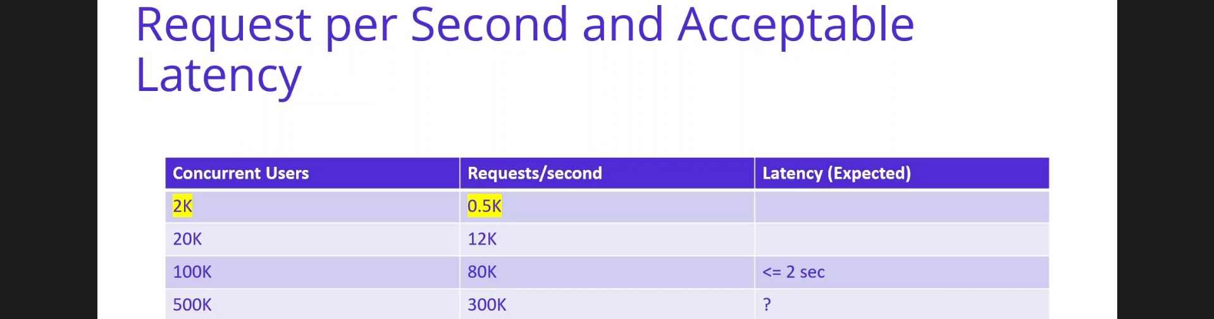
   1. As you can see in this table, we will start small e-commerce app which has 2k(2 thousands) concurrent users and gets 5 hundred (.5k) request per second.
   2. So, if you don’t expect any growth in your custom base, you can pick up monolithic architecture.  
      Even if we expect growth of users to 500K or millions of users, it is good to start with simple and evolve step by step.
   3. So, this is what we will do in this course.
   4. We will start with a small e-commerce app. When the app grows and concurrent users and incoming requests will be increased, we will be evolving our architecture to ms architecture.
5. So, we saw when to use monolithic architecture and benefits of monolithic architecture.